Experiment no-19
Online Veterinary Care System
AIM:
To develop an online veterinary care website for submitting animal complaints and consulting doctors.
PROCEDURE:
- Create an HTML file and design the webpage using HTML and CSS.
- Add registration, login, and animal complaint forms.
- Use JavaScript to submit complaints and display their status.
- Add doctor details, feedback, and news sections.
- Run the webpage in a browser and test the forms.
Sample Code:
<!DOCTYPE html>
<html>
<head>
<title>VetCure</title>
<style>
body { font-family: Arial; background: #e8f5e9; }
h1 { color: green; }
input, textarea, button {
display: block;
margin: 10px;
padding: 8px;
}
</style>
</head>
<body>
<h1>VetCure - Animal Care</h1>

<h2>Submit Animal Complaint</h2>
<form onsubmit="submitComplaint(event)">
<input id="animal" placeholder="Animal Name" required>
<textarea id="symptoms" placeholder="Symptoms" required></textarea>
<button type="submit">Submit Complaint</button>
</form>
<p id="result"></p>
<script>
function submitComplaint(event) {
event.preventDefault();
document.getElementById("result").innerHTML =
"Complaint submitted successfully!";
}
</script>
</body>
</html>
Sample Output:
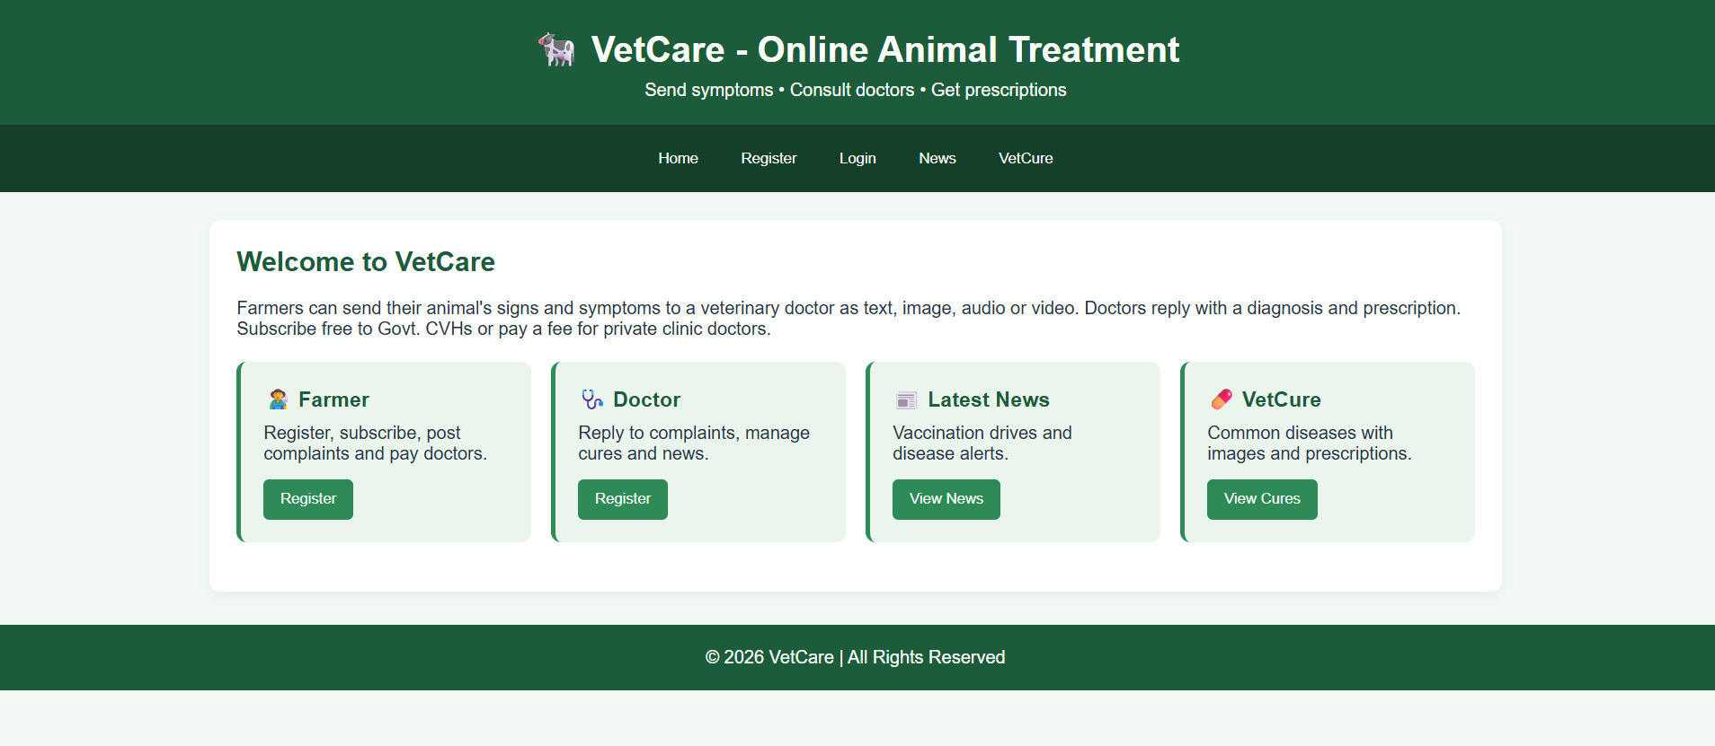

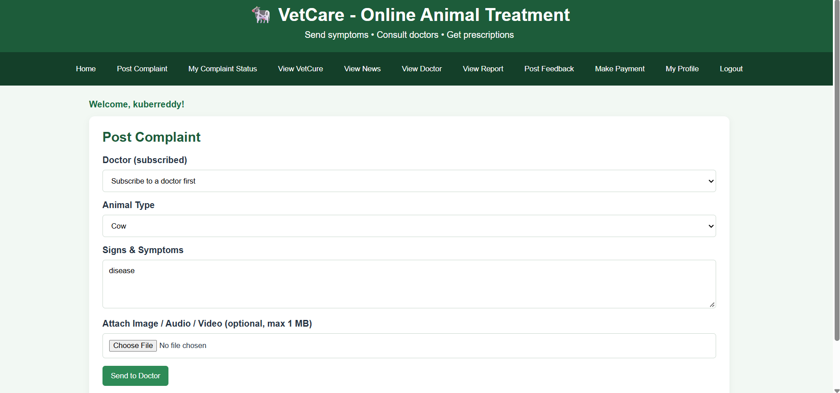
Result:
Thus, the VetCure website was created successfully to demonstrate animal complaint submission.

